Day 3 task 3

**Minikube and kubectl**

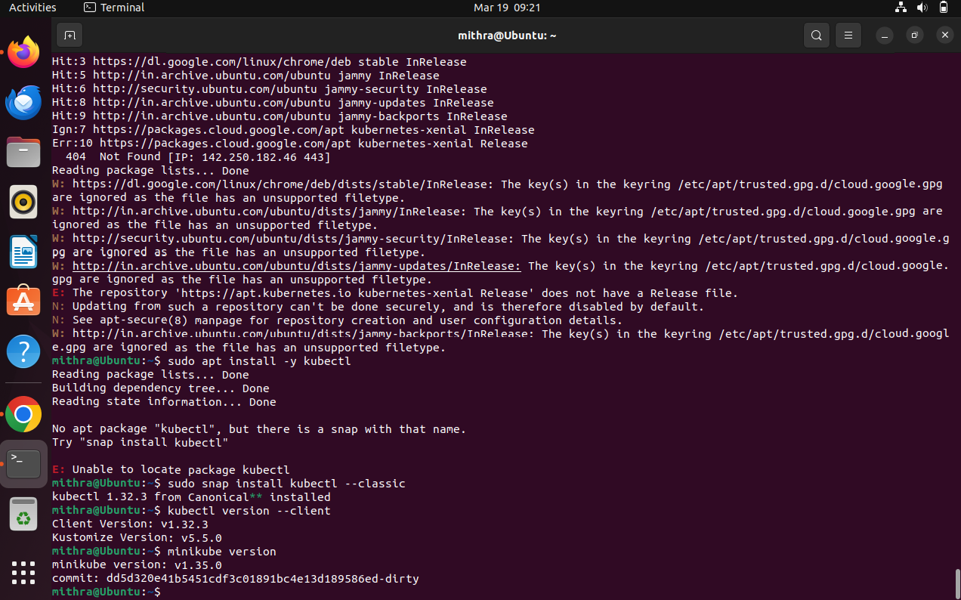

**Vs code installation with terraform and aws extension**



**Aws cli download and install**

